**Chapter 1 *Urban Service***

**Management Science**: A discipline in which mathematical methods are applied to management problems in pursuit of optimal solutions that cannot readily be obtained by common sense.

Example 1. Steve’s job is to collect money from parking meters. The street map of the next area is shown below. What route would you like to suggest to him?

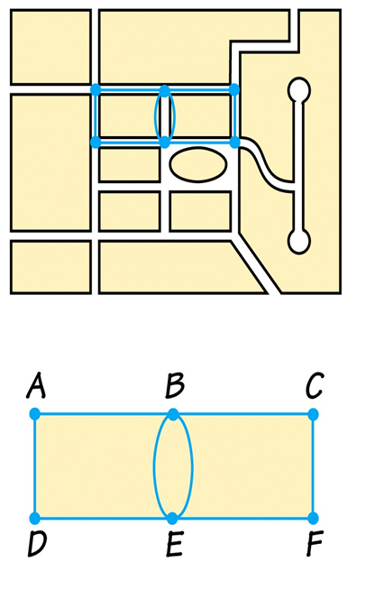

**1. Graph**

**Definitions**:

• A **graph** is a finite set of dots and connecting links.

• A **dot** is called **vertex(vertices)**.

• A **links** is called an **edge**.

• A **path** is a connected sequence of edges showing a route on the graph that starts at a vertex and ends at a vertex

• A c**ircuit** is a special path that starts and ends at the same vertex.

Example 2. Determine the number of vertices and edges in the graphs below.

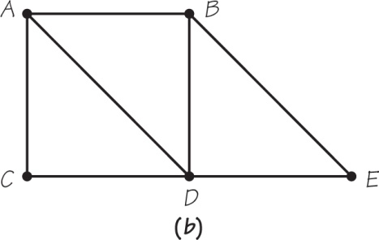 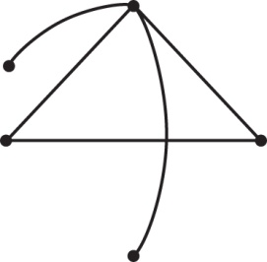

Example 3. Using the number sequence of edges to represent a path and a circuit.

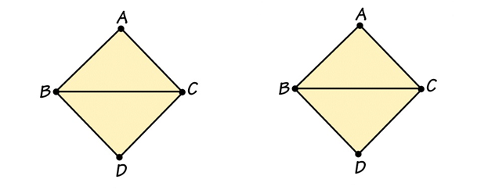

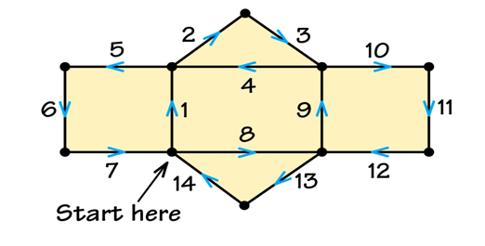

In e.g. 1, we arranged our route so that we don’t drive on the same road more than once.

**Definition:** Circuits that cover every edge once and exactly once are called ***Euler circuits***.

Workout 1 Draw a graph with a map of parking meters.

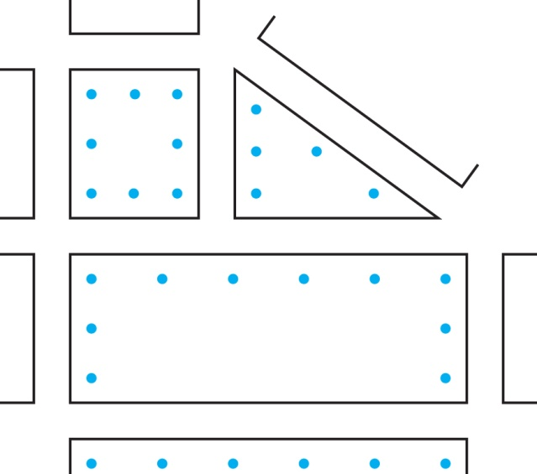

Example 4.

a) Which of the diagrams can be drawn without lifting your pencil from the paper, and every edge can only be drawn once.

b) Which can be drawn as in (a), but with the additional requirement that you end the drawing at the starting point.

c) For those you can draw under the requirement of (b), is the way to draw Euler circuit unique?

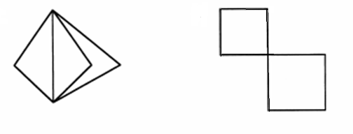 

**2. Finding Euler Circuits**

We like to know the answers of the two questions:

(a) Is there a way to tell that a graph has or has no an Euler circuit?

(b) If Euler circuit exists, is there a way to find an Euler circuit?

**Definition:** The **valence** of a vertex in a graph is the number of edges meeting at the vertex.

Example 5. Find the valence of each vertex in each graph.

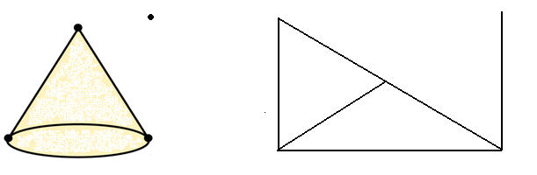

**Definition**: A graph is **connected** if for every pair of its vertices there is at least one path of one or more edges connecting the two vertices.

Example 6. Identify whether each of the following graphs is connected.

I) figure-01-07.JPG                                               000264C6
production                     B8414D3D:

II) III)

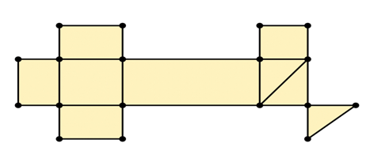 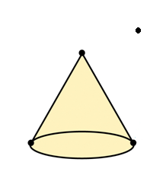

**Euler Theorem**:

(a) If a graph is connected and has all valences even, then the graph has an **Euler circuit.**

(b) Conversely, if a graph has an **Euler circuit**, then the graph must be connected and all its valences must be even numbers.

Example 7. Identify whether the graphs in Example 6 have an **Euler circuit.**

**Note**:

• The Euler Theorem tells when an Euler circuit exists, but does not tell how to find it.

• When asked to find an Euler circuit, we should use Euler Theorem to check the existence.

• When a graph is not complicated, we may find Euler circuit (if it exists) by trial and error without getting really confused.

• When a graph is complicated, we may use computers to find Euler circuit if it exists.

**3. Circuits with reused edges**

The Euler circuit may not exist. But life has to go on, that means, sometimes, we have to drive through the same street(s) for more than once, but still wish to minimize the distance to be traveled.

**Simplified Chinese postman problem**:

Assume that all streets has the same length, we only need to count the number of reused street(s). The fewer the reused street(s), the better.

**Definition**: Adding edges to a graph so as to make all valences even is called **eulerizing** the graph.

After eulerizing a graph, an Euler circuit exists.

 

Example 8. Eulerize the following graphs.

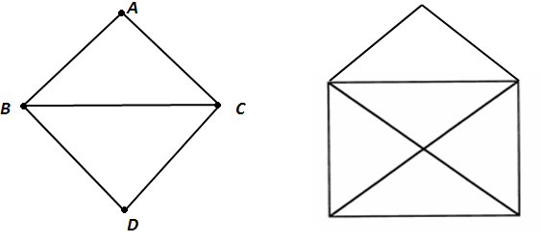 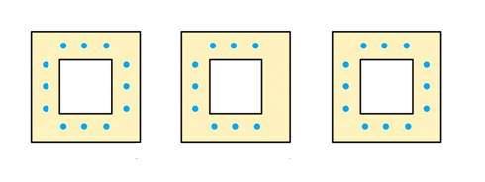

**Chinese postman problem**:

Find a circuit on a graph that covers every edge of the graph at least once and that has the shortest possible length.

Example 9. Eulerize the following graph. 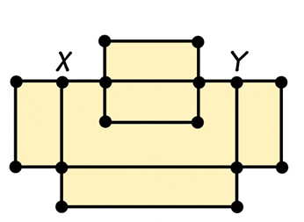

**Comment**:

• Eulerizing a graph is just like finding a route with some streets reused.

• To eulerize a graph, the first step is to locate all vertices with odd valence. Then add as few as possible edges to eulerize the graph.

**4. Rectangular network**

**Definition**: If a street network is composed of a series of rectangular blocks that form a large rectangle a certain number of blocks high by a certain numbers of blocks wide, the network is called rectangular.

What is special about a rectangular network?

• Any inner vertex has valence of 4.

• Any corner vertex has valence of 2.

• Any side vertex has valence of 3.

**Note**: Eulerizing a rectangular network is to work on the side vertices such that number of reused edges is minimized.

Example 10. Eulerize the following rectangular networks.

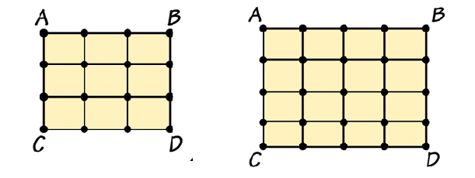

“Edge walker” technique- Start with a corner of the graph and travel clockwise around the rectangle, connecting each odd vertex to the next vertex using a new edge.

Example 11. For which of the two situations below is it desirable to find an Euler circuit or an efficient eulerization of a graph?

I. A veteran planning a visit to all the war memorials in Washington D.C. plots a route to follow.

II. Painting the lines down the center of the roads in a town with only two way road.